School Trips to Finlaystone Country Estate

Finlaystone Country Estate is one of Renfrewshire’s leading visitor attractions, with over 60,000 visitors and 3,000 school children each year. Located on the A8, 20 minutes west of Glasgow Airport, the estate is within easy travelling distance and has a great deal to offer any visiting school.

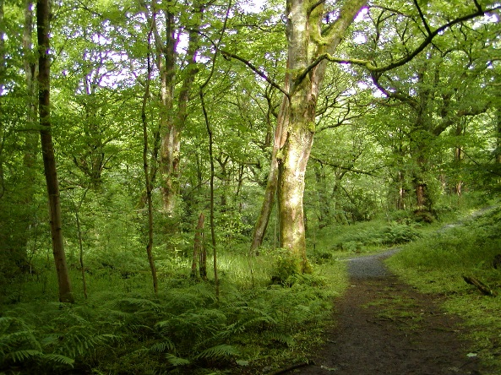
On arrival
Our Ranger Service will meet your coach and then take you to your designated indoor base area where you can leave bags and coats etc. Each class teacher will be given their timetable for the day which will include a Ranger led guided walk or activity, time in the shop, free time and time for your picnic. Packed lunches can by provided by the tea room on request approx ‘ £3.50 per child call The Cafe on 01475 540284

Ranger led walks/activities
Our Ranger Service will provide each class with a one hour long guided walk/activity free of charge. Each walk covers one topic and will be carried out by one of our highly trained members of staff. The activities are tailored to meet the needs of each group and every effort is made to accommodate groups or individuals with special requirements and to cater for pupils at all levels. Below you will find a list of our most popular topics and the minimum primary age group for which we consider they are suitable.
Topics | P1 | P2 | P3 | P4 | P5 | P6 | P7
My First Nature Walk | Yes | Yes | Yes | No | No | No | No
Sensational Senses | Yes | Yes | Yes | Yes | Yes | No | No
Art in Nature | Poss | Yes | Yes | Yes | Yes | Yes | Yes
Tracks and Trails | No | Yes | Yes | Yes | Yes | Yes | Yes
Living things | No | Poss | Yes | Yes | Yes | Yes | Yes
How the Garden Works | No | Poss | Yes | Yes | Yes | Yes | Yes
Mini-beast Safari | Yes | Yes | Yes | Yes | Yes | No | No
Bio-diversity | No | No | Poss | Yes | Yes | Yes | Yes
Natural resources | No | Poss | Yes | Yes | Yes | Yes | Yes
Renewable Energy | No | Poss | Yes | Yes | Yes | Yes | Yes
Plants & Animals | No | Poss | Yes | Yes | Yes | Yes | Yes
Trees | No | Poss | Yes | Yes | Yes | Yes | Yes
Recycling * | No | Poss | Yes | Yes | Yes | Yes | Yes
Ranger Hike | No | No | Yes | Yes | Yes | Yes | Yes

*Please bring your own 500ml & 2ltr plastic bottle for this activity

Please contact us as soon as possible if you wish to discuss the possibility of our Rangers providing any other topics.
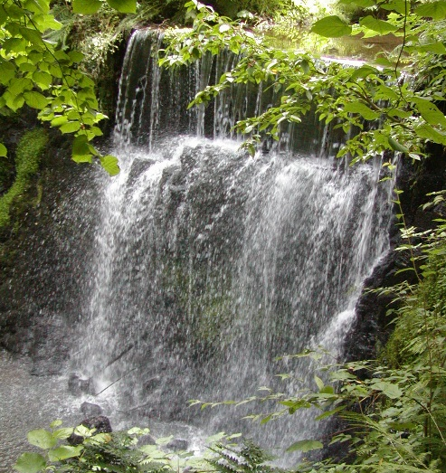
What else do we offer?
Finlaystone Country Estate comprises 150 acres, of which 10 acres are formal gardens and 140 acres are mixed woodlands with a network of trails, play areas, pond and burn with spectacular waterfalls.

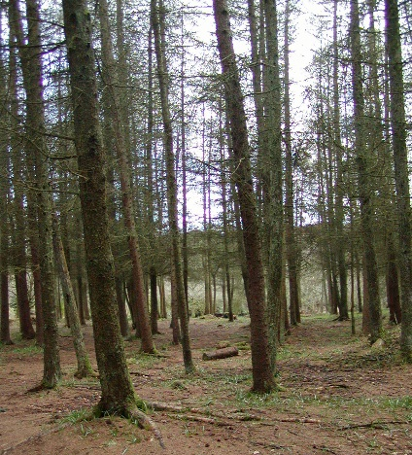
The ‘Eye-Opener’ Visitor Centre is the wildlife centre with displays and houses the ‘Dolly Mixture’, disabled toilet and a gift shop stocked with goods, many at pocket money prices. Each class will be allocated a 15 minute time slot for the shop. The ‘Dolly Mixture’ is a doll museum with an international collection of dolls collected by the MacMillan family.

A mixture of dense conifer plantations and open broad-leaved woodlands cover the estate complemented by their associated woodland flora and fauna. Woodland clearings provide areas for BBQ’s, picnics and play. Throughout the woodland are extensive timber play areas from fort & wigwams, tram, train and pirate ship to slides & swings.

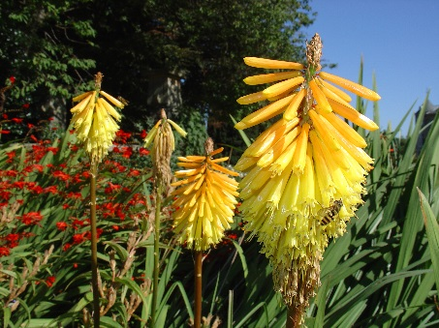
So how much does it cost?
It costs £4.00 for each child visiting the estate and £5.00 for adults (one adult is allowed free entry with every 10 paying children).
Each group can choose their Ranger led guided walk or activity, which is at no extra cost, but is subject to availability.

What to bring?
Good footwear and outdoor clothing are always recommended. Wellington boots are advised for some activities. You will need your own picnics.

Booking & more information
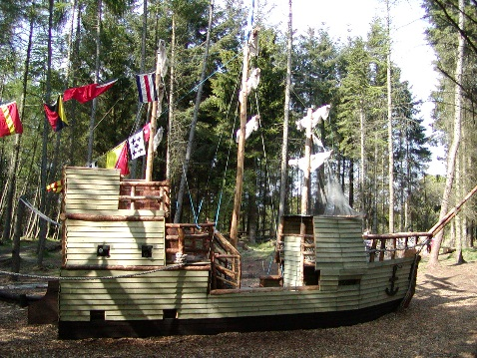
For more information or to book simply telephone Norah
today on 01475 540505 to check availability (we do get fully booked quickly, especially for May/June) then fill in & either fax or email back the booking form in this pack.
Thank you for your valuable time and hoping you will visit us soon.
Head Ranger
Finlaystone Country Estate, Langbank, Renfrewshire, PA14 6TJ
Telephone/fax 01475 540505 email shop@finlaystone.co.uk www.finlaystone.co.uk

Finlaystone School Trip Booking Form
Please telephone 01475 540505 to check availability first
and then fax this booking form to 01475 540505. Or email to shop@finlaystone.co.uk

School Name ____________________________________________________________
Address _____________________________________________________________
_____________________________________________________________
Contact Name____________________________________________________________
Telephone _______________________email_________________________________
Day/Date of Visit _________________________________________________________
Arrival Time _________________ Departure Time____________
Total number of Children ______ Number of Adults___________
Method of transport: coach/minibus/other
Mobile telephone number on day of visit in case of emergency______________________
Method of Payment Cash / Cheque on the day / Invoice*

Class Teacher | No of pupils | Primary | Ranger Topic  (One topic per class) | Special Needs Children
Mrs Example | 28 | P2 | My First Nature Walk | 1 in a wheelchair

Have you visited before? Yes / No If yes, please circle when 2013, 2012, 2011, 2010, 2009, 2008.

We do / do not authorise you to photograph or advise the local press of our visit.

We agree to pay a £37.50 cancellation fee per activity if we cancel within one week of the planned visit and this fee will be invoiced to us. *We also understand that invoices must be paid within 14 days of the invoice date or a 10% surcharge will be made.

Signature _________________________ Print __________________________

Please note: Finlaystone Ranger Service expects schools to place all recyclable items i.e. cans, plastic bottles etc in the appropriate bags – thanks for your help in this matter.

FCE use only: booking accepted Yes / No entered in diary on by Paid Yes / No

