Craft & Tabletop Opportunities at Finlaystone Estate

Located directly between the walled garden and the Visitor centre are the old stables which are opened to the public in the form of small craft stalls/shops. They are available for hire by the day, weekend or slightly longer period. Each stable costs £25 per day (£40 weekend) to hire, but they are all capable of taking two stall holders, allowing you to share the cost!

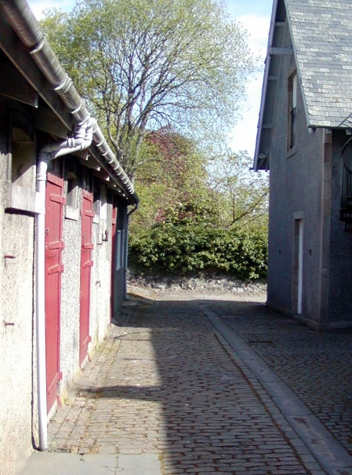
Stable 1 (southern end) 3.5m x 4m
Contains large welsh dresser, 2 tables & 2 chairs & power points
Stable 2 (middle) 2.8m x 4m
Contains 2 tables & 2 chairs& power points

Stable 3 (northern) 2.8m x 4m
Contains 2 tables & 2 chairs& power points

Box Room 6.3m x 3.3m
Contains large table, two shelf units, 2 chairs, sink & power points.

Our old ‘Cart Shed’ has been replaced by a new timber framed structure including two rooms which are now available for stalls. One room is ‘open-fronted’ whilst the other has glass doors. Each room has lighting & power points and can take up to 6 table based stalls. In addition, there is also the Victorian Room, the Old Laundry Building and if you have your own stall/gazebo etc space is always available in the walled garden all at the same price of £25 per table based stall on event days or £15 per stall on any other day. Please remember to check www.finlaystone.co.uk for details of our events.

Terms and conditions
- Finlaystone Country Estate reserves the right to cancel future bookings (with full refund) if your stall does not comply with information on your booking form or meet our standards.
- No food, drink or electrical items to be sold
- Hirers accept full responsibility & liability for any accidents, loss or injury arising out of or in connection with their stalls/activities and indemnify Finlaystone Country Estate accordingly.

Hours of opening
- Set up from 9.00am – 11.00am
- Stalls open from 11.00am – 4.30pm
- Clear up 4.30 onwards.

Payment & cancellation
- Full payment on booking by cheque or credit card (11am-4pm only)
- If you cancel 2 weeks prior to the date a refund will be given (minus a £10 admin charge)
- If you cancel less than 2 weeks – no refund unless a suitable replacement can be found. If we are able to find a replacement then a refund will be given (minus a £10 admin charge)

To make your booking or to find out more information please telephone Norah on 01475 540505
or email shop@finlaystone.co.uk

Finlaystone Country Estate
Langbank, Renfrewshire, PA14 6TJ.
Tel/fax 01475 540505
Craft or Tabletop Booking Form

Name ________________________________________________
Address ________________________________________________
________________________________________________
Telephone ___________________Email_________________________
Type of Stall _______________________________________________
I wish to apply for a stall and agree to the terms & conditions specified below.
Signed _________________________ Date___________________
NB: Please indicate date(s) & preferred room on the attached but space will be allocated & confirmed only when full payment is received.
Terms and conditions
- Finlaystone Country Estate reserves the right to cancel future bookings (with full refund) if your stall does not comply with information on your booking form or meet our standards.
- No food, drink or electrical goods to be sold.
- Hirers accept full responsibility & liability for any accidents, loss or injury arising out of or in connection with their stalls/activities and indemnify Finlaystone Country Estate accordingly.

Hours of opening
- Set up from 9.00am – 11.00am
- Stalls open from 11.00am – 4.30pm
- Clear up 4.30 onwards.

Payment & cancellation
- Full payment on booking by cheque or credit card (11am-4pm only)
- If you cancel 2 weeks prior to the date a refund will be given (minus a £10 admin charge)
- If you cancel less than 2 weeks – no refund unless a suitable replacement can be found. If we are able to find a replacement then a refund will be given (minus a £10 admin charge)

Payment method : Credit Card by telephone Monday – Friday 11am – 4pm or
Cheque enclosed for £ (payable to Finlaystone Country Estate)

Please email, post or fax this booking form to:

Norah Millar, Finlaystone County Estate, Langbank, Renfrewshire, PA14 6TJ.
Tel/fax 01475 540505
Email: shop@finlaystone.co.uk

Please check our web site www.finlaystone.co.uk for details of the events & activities we are holding throughout the year.

For any further information please telephone
Norah on 01475 540505 or email shop@finlaystone.co.uk

