School Trips to Finlaystone Country Estate

Finlaystone Country Estate is one of Renfrewshire’s leading visitor attractions, with over 60,000 visitors and 3,000 school children each year. Located on the A8, 20 minutes west of Glasgow Airport, the estate is within easy travelling distance and has a great deal to offer any visiting school.

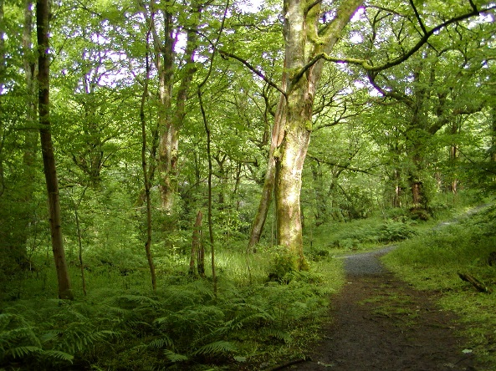
On arrival
Our Ranger Service will meet your coach and then take you to your designated indoor base area where you can leave bags and coats etc. Each class teacher will be given a map of the estate, their specified group timetable that gives their Ranger Led Activity time, shop time (if required). The rest of the time you can enjoy the outdoors!

Ranger led walks/activities
Our Ranger Service will provide each class with a one-hour Ranger Activity which is included within the cost of £4. Each activity covers one topic and will be carried out by one of our highly trained members of staff. The activities are tailored to meet the needs of each group and every effort is made to accommodate groups or individuals with specific requirements and to cater for pupils at all levels. Below you will find a list of our most popular topics and the minimum primary age group for which we consider they are suitable.
Topics | P1 | P2 | P3 | P4 | P5 | P6 | P7
My First Nature Walk | Yes | Yes | Yes | No | No | No | No
Sensational Senses | Yes | Yes | Yes | Yes | Yes | No | No
Art in Nature | Poss | Yes | Yes | Yes | Yes | Yes | Yes
Tracks and Trails | No | Yes | Yes | Yes | Yes | Yes | Yes
Living things | No | Poss | Yes | Yes | Yes | Yes | Yes
How the Garden Works | No | Poss | Yes | Yes | Yes | Yes | Yes
Mini-beast Safari | Yes | Yes | Yes | Yes | Yes | No | No
Bio-diversity | No | No | Poss | Yes | Yes | Yes | Yes
Natural resources | No | Poss | Yes | Yes | Yes | Yes | Yes
Renewable Energy | No | Poss | Yes | Yes | Yes | Yes | Yes
Plants & Animals | No | Poss | Yes | Yes | Yes | Yes | Yes
Trees | No | Poss | Yes | Yes | Yes | Yes | Yes
Recycling * | No | Poss | Yes | Yes | Yes | Yes | Yes
Ranger Hike | No | No | Yes | Yes | Yes | Yes | Yes

Please contact us as soon as possible if you wish to discuss the possibility of our Rangers providing any other topics.

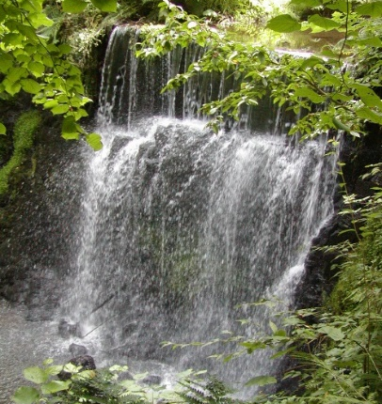
What else do we offer?
Finlaystone Country Estate comprises 150 acres, of which 10 acres are formal gardens and 140 acres are mixed woodlands with a network of trails, play areas, pond and burn with spectacular waterfalls.

The Visitor Centre is the wildlife centre with displays and houses the ‘Dolly Mixture’, accessible toilet and a gift shop stocked with goods, many at pocket money prices. Each class will be allocated a 15-minute time slot for the shop. The ‘Dolly Mixture’ is a doll museum with an international collection of dolls collected by the MacMillan family.
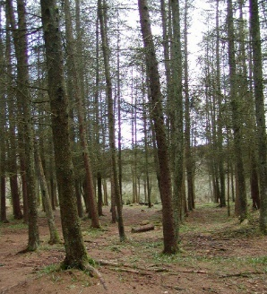
A mixture of dense conifer plantations and open broad-leaved woodlands cover the estate complemented by their associated woodland flora and fauna. Woodland clearings provide areas for BBQ’s, picnics and play. Throughout the woodland are extensive timber play areas from fort & wigwams, tram, train and pirate ship to slides & swings.

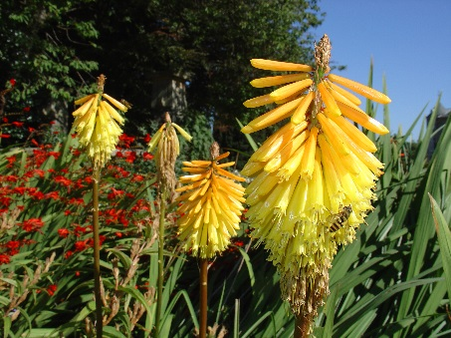
So how much does it cost?
It costs £4.00 for each child visiting the estate and £5.00 for adults (one adult is allowed free entry with every 10 paying children).
Each group can choose their Ranger led guided walk or activity, which is at no extra cost, but is subject to availability.

What to bring?
Suitable clothing and footwear. Wellington boots are advised for some activities. You will need your own picnics if you don’t get the Café’s packed lunch.

Café
Packed lunches can be provided by the tea room on request £3.50 per child. Just call Jill on 07795606730. A discounted price can be offered to large school groups, and discounted prices for tea/coffee are available for teachers and coach drivers.

Booking & more information
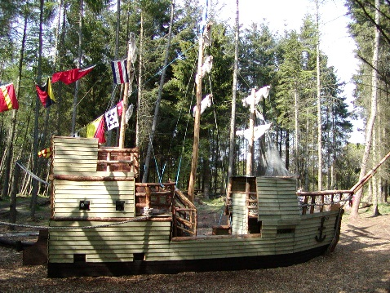
For more information or to book simply telephone Norah
today on 01475 540505 to check availability (we do get fully booked quickly, especially for May/June) then complete and email the booking form in this pack.
Thank you for your valuable time and hoping you will visit us soon.

Tamar Duncan, Head Ranger, Finlaystone Country Estate, Langbank, Renfrewshire, PA14 6TJ
Telephone: 01475 540505
Email: shop@finlaystone.co.uk www.finlaystone.co.uk
Finlaystone School Trip Booking Form
Please telephone 01475 540505 to check availability first by calling. To book complete and email the form below to shop@finlaystone.co.uk

School Name: ______________________________________________________________
Address: _____________________________________________________________
_____________________________________________________________
Contact Name: ____________________________________________________________
Telephone: _____________________
email *__________________________________________________________________
Day/Date of Visit: _________________________________________________________
Arrival Time: _________________ Departure Time: ____________
Number of Children: ______ Number of Adults: _______
Method of transport: coach / minibus / other
Mobile telephone number on day of visit in case of emergency: ______________________
Method of Payment: Cash / Cheque on the day / Invoice*

£4 per child entry gives one-hour Ranger Led Activity at the usual cost of £40 per hour.
Discount: For every 10 paying children, one adult goes free.

Class Teacher | No of pupils | Primary | Ranger Topic  (One topic per class) | Special Needs Children
Mrs Example | 28 | P2 | My First Nature Walk | Wheelchair

Falconry Centre
If you would like to visit the Falconry Centre on site it’s an extra £1 per child by cash on the day. Supervising Adults will go free.

We do / do not authorise you to photograph or advise the local press of our visit.

We agree to pay a £40 cancellation fee per activity if we cancel within one week of the planned visit and this fee will be invoiced to us. *We also understand that invoices must be paid within 14 days of the invoice date or a 10% surcharge will be made.

Signature: _____________________________ Print: _________________________________

Finlaystone is committed to sustainable business. Please recycle your waste on your visit including cans, plastic bottles and cardboard food packaging in the blue bags separately from land fill. Thanks very much.

FCE use only: Booking accepted Yes / No
Entered in diary on: ___________ by: _________
Paid: Yes / No

